Regulatory Advice Enquiry Form

Please use this form to contact Animals in Science Regulation Unit (ASRU) if you require regulatory advice. Our aim is to respond to your request within 5 working days

Do not use this form to:
- Report a PPL Standard Condition 18
- Report a potential non-compliance
- Discuss issues related to drafting a project licence application

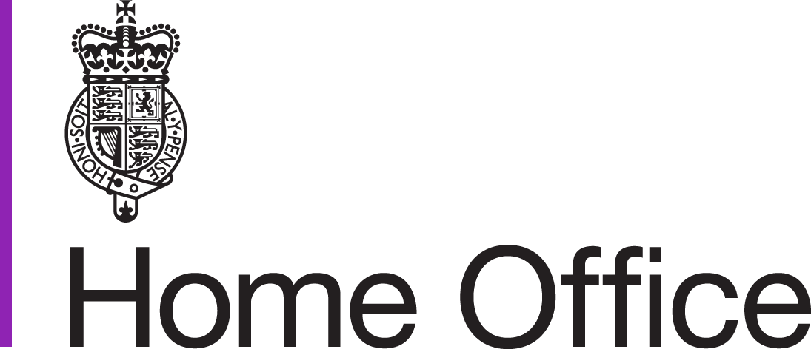
Please clearly title your document: ‘ASRU_Establishment Name_Your Name_ Date_’ and send to the Regulatory Advice Team with the subject heading ‘Regulatory Advice Request Establishment [Number]’.

Establishment Licence Name and Number

In relation to your enquiry, which of the following best describes you?
PELh ☐ PPLh ☐ Other ☐ NVS ☐ NACWO ☐ NIO ☐ NTCO ☐ NPRC☐
Choose an item.
PPLh/PILh Number if applicable:
If selected Other above, please specify:

IS THERE AN IMMEDIATE OR ONGOING ANIMAL WELFARE CONCERN?
YES ☐
NO ☐
If answered YES above, please describe:

IS A RESPONSE REQUIRED URGENTLY?
YES ☐
NO ☐

In relation to your enquiry, which of the following best describes the topic you are contacting us about today?
PPL Authorities ☐
PIL Authorities ☐
Training Requirements ☐
Potential Refinements ☐
Additional Harms to Animals ☐
General Enquiry ☐

Please provide details of your enquiry, providing PPL/Protocol number if applicable:

Date

******************************For official use******************************************

Regulatory Advice Given

Name

Date

